Gandi Domain Transfer inbound – with Zone Entries
- Create Zone file
In old Gandi site, go to
Go to DNS Zones, and click on create
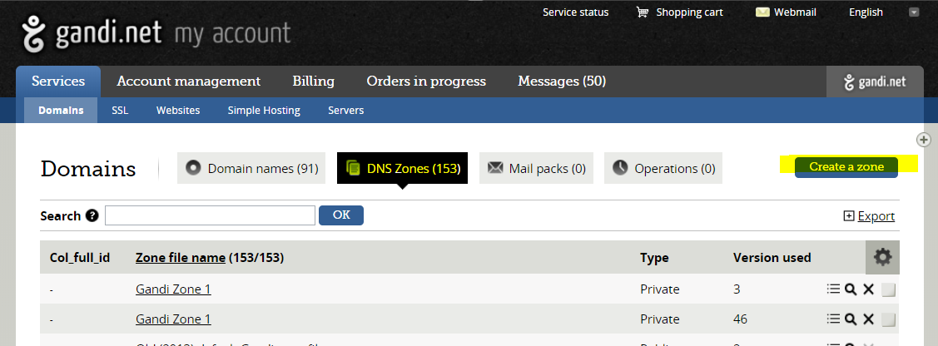
Enter the domain you are going to Transfer, Submit
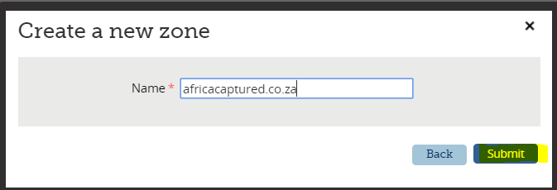
Add all the zone files given by Current Registrar, and add ours if they take mail
Do not add Start of Authority (SOA) or Name Servers (NS) or Localhosts
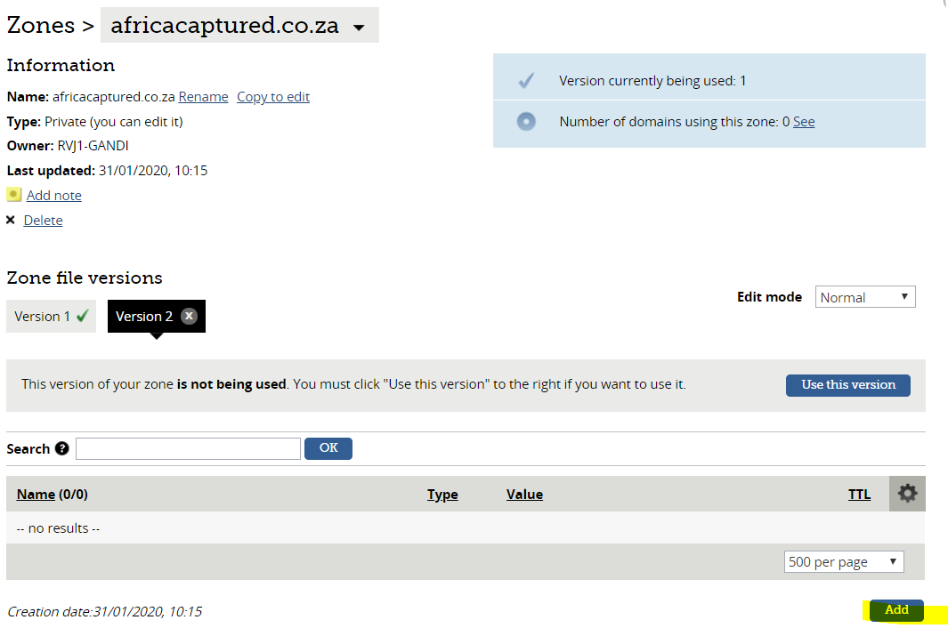
Example
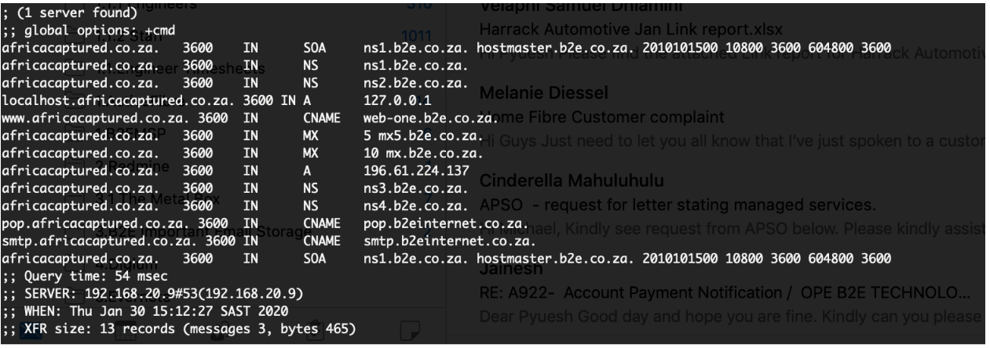
When all the records are added, click on use this version
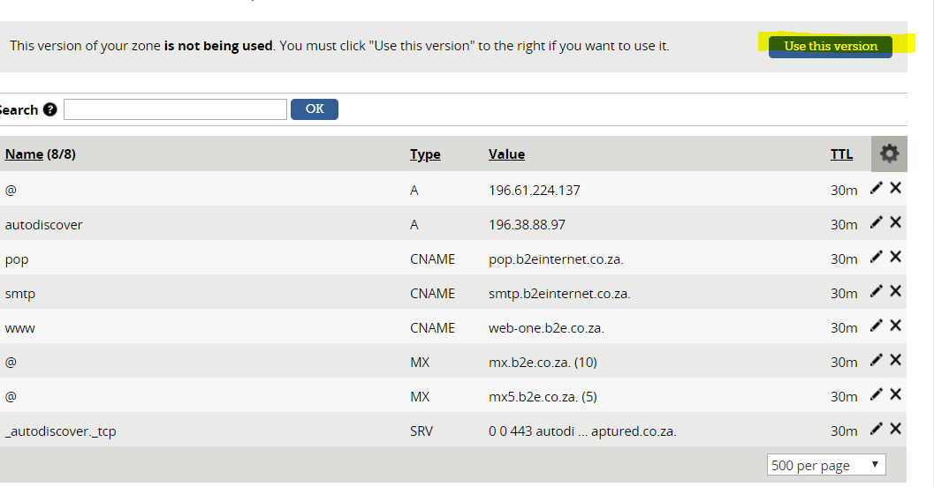

- Transfer Domain
.co.za Domains do not require Authorisation codes.
All other TLDs would need an Authorisation code, and needs to be paid
At the bottom of the Gandi Page, click on Transfer
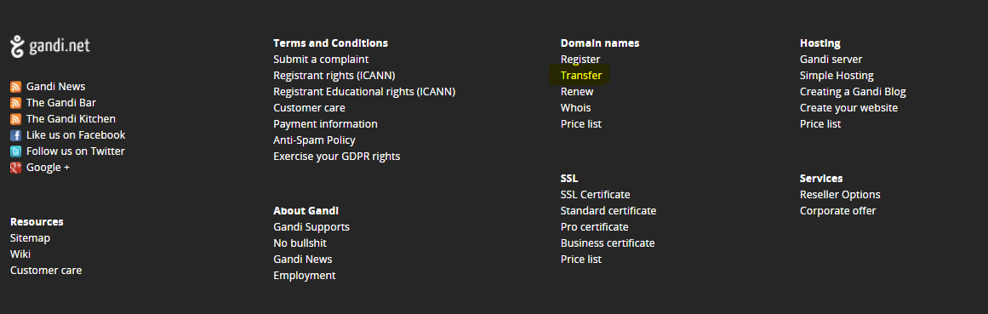
Enter Domain Name, and Transfer
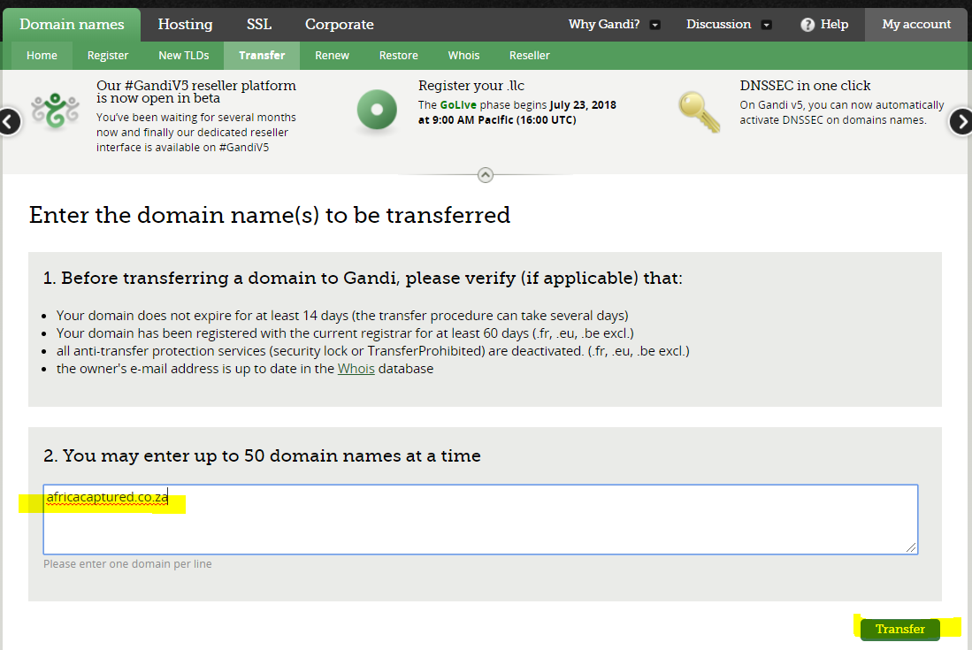
Click on Submit
Gandi will ask for the Authcode if it needs one (Which you will get from Registrar)
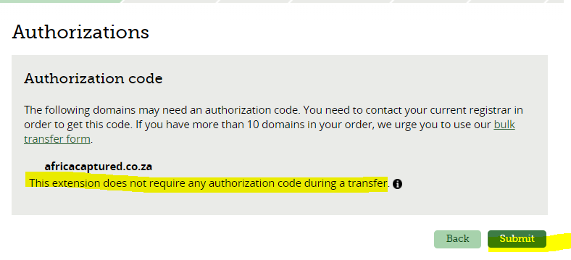
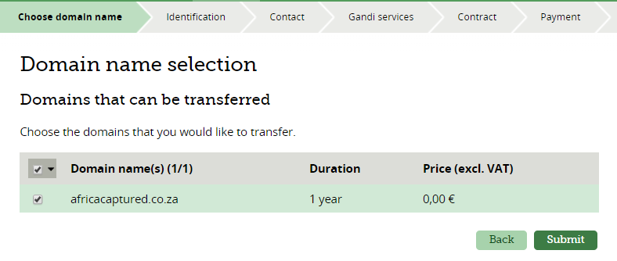

Or other TLDs – will need payment at the end (Make sure the client is being charged) 
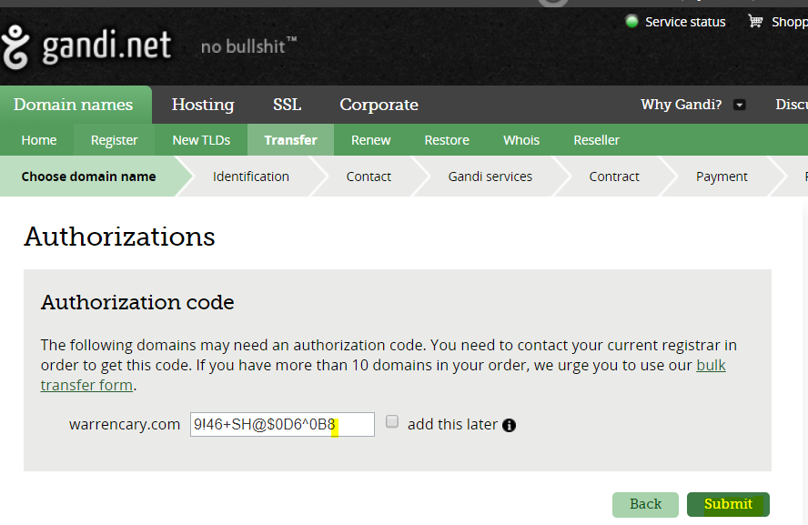
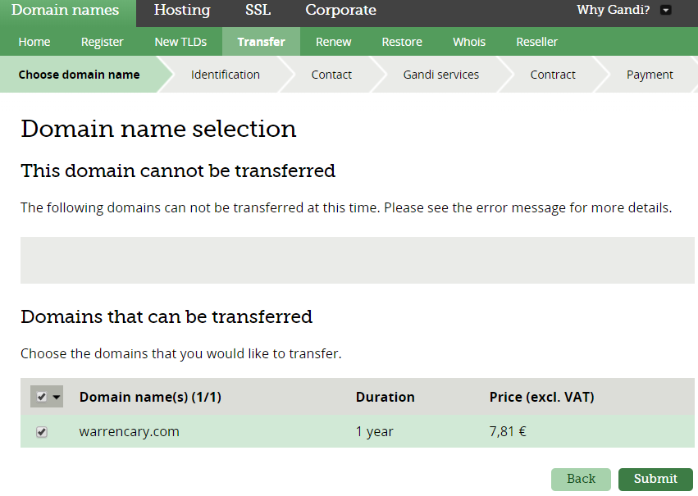

Enter our Handle : RVJ1-GANDI at owner, submit

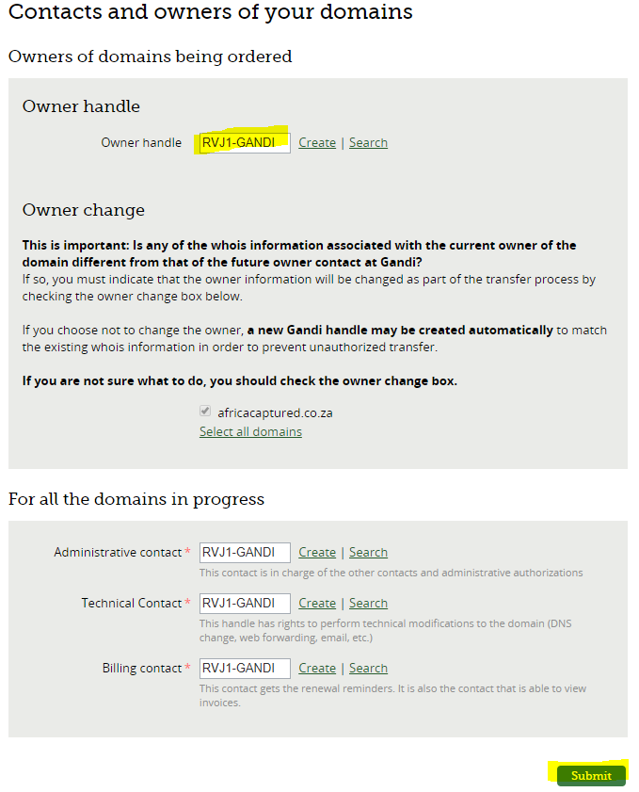

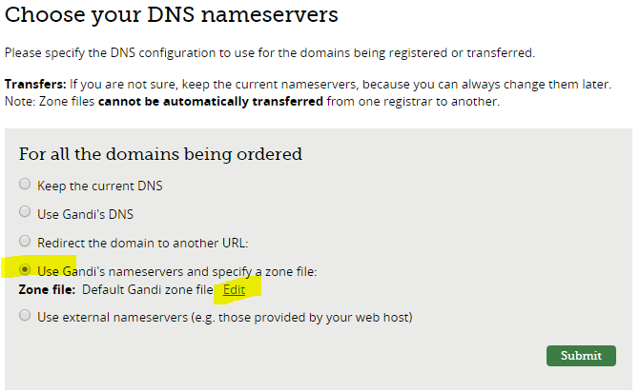
Choose the DNS ZONE File you created for the domain
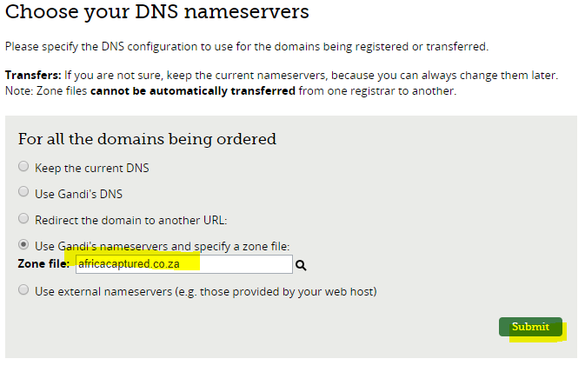
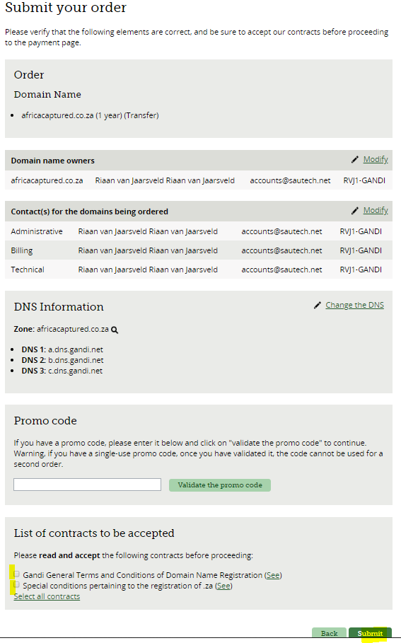
Accounts@sautech.net and the current registrar will get an email to accept :
We need to accept our one and they need to accept theirs

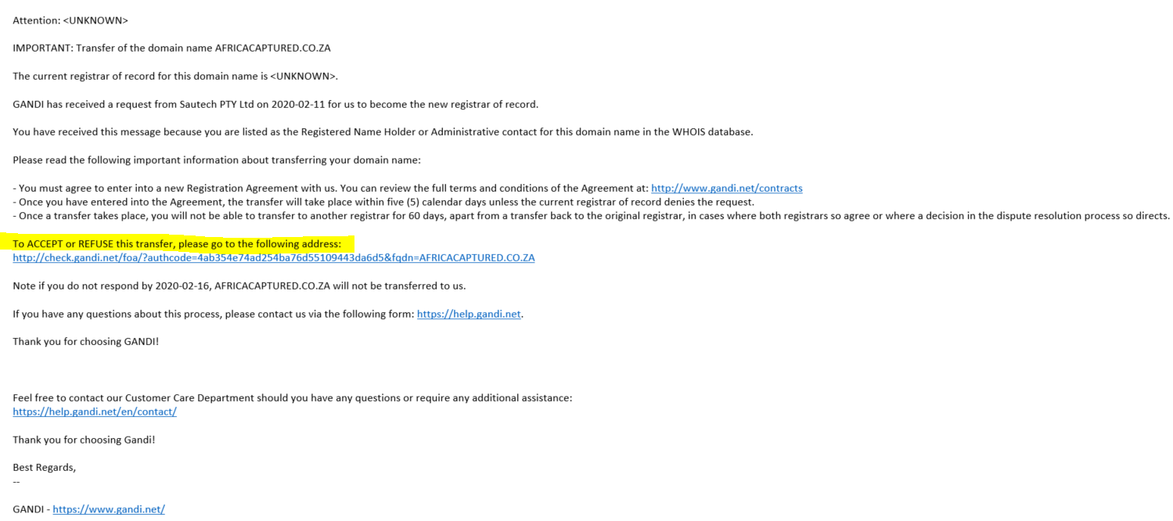
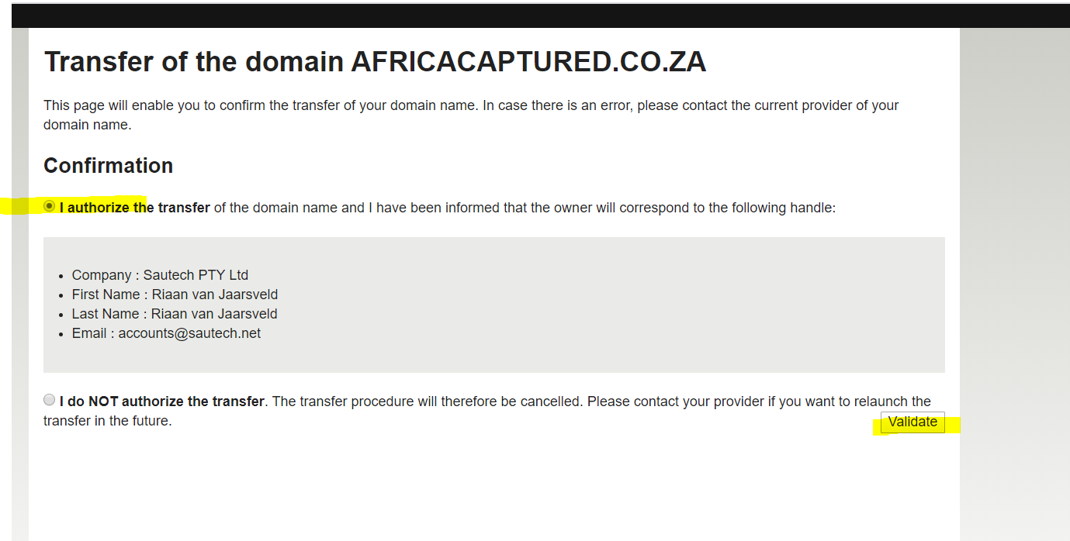

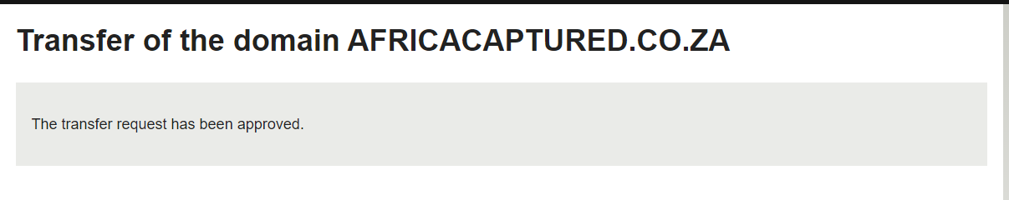
You will see the progress in our account under Orders in Process
